SRINIVAS UNIVERSITY
Mangalore-575001, Karnataka (India)

Research Scholar’s Profile
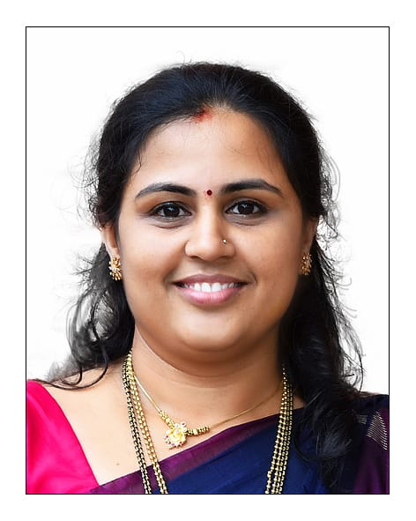

Ms. RAJESHWARI M

Research Area- Cognitive IoT:
When demands are high and resources are yet to be investigated, it is wise to inspire development through the merger of technologies and eventually lead to exclusive structures. Today, IoT or Internet of Things has also progressed to deliver as cognitive IoT. Cognitive IoT is the method of integrating cognitive computing technologies on the data generated by smart devices. In Cognitive computing, a device is configured to simulate human cognition. It uses machine learning algorithms to transform smart devices. IoT devices will respond to environmental changes without human involvement. The local and networked sensors will foresee exterior world through several expert knowledge sharing and data. That will be associated with processing, understanding and making sense of the world.

Objectives:
Goal of this research is
- To analyse the IoT applications.
- To study available machine learning algorithms in Cognitive IoT applications.
- To find new possibilities in Cognitive IoT and its applications to the public.

Journal Publications:
- Rajeshwari M & Dr Krishnaprasad K (2019). IT Consulting and Software Services by Outsourcing Makes a Company World Leader- A Case Study of Infosys Ltd. IJCSBE, 3(2),1-13.
- Rajeshwari M (2020). “The Role of Cognitive IoT in the Analysis of Student Classroom Behavior for the Enhanced Teaching-Learning Experience”, National Level Paper Contest for Ph.D. students.
- Rajeshwari M & Dr Krishnaprasad K (2020). IBM Watson Industry Cognitive Education Methods. IJCSBE, 4(1), 38-50
- Rajeshwari M & Dr Krishnaprasad K (2020). A Modified Conceptual Model to Improve Classroom Education with Cognitive Learning. IJAEML, 4(1), 61-75.
- Rajeshwari M & Dr Krishnaprasad K (2020). Application of IoT in Analyzing Cognitive Skills of Students-A Systematic Literature Review. 5(1), 158-184.
- Dr Krishnaprasad K , Vinayachandra,Geetha Poornima K, & Rajeshwari M (2020). IJAEML, 4(1), 112-130.
- Dr Krishnaprasad K , Vinayachandra,Geetha Poornima K, & Rajeshwari M (2020). Literature Review of Applications of ICT on Solar Cold Chain. IJAEML, 4(1), 93-111.
- Dr Krishnaprasad K , Vinayachandra,Geetha Poornima K, & Rajeshwari M (2020). Effect of COVID-19 on Technology Penetration: a Predictive Analysis. Alochana Chakra Journal, IX(V), 2949-2967.
- Vinayachandra,Geetha Poornima K, Rajeshwari M, & Dr Krishnaprasad K (2020). Role of Technologies in the Development of Smart and Secure Public Voting Systems – a Review of Literatures. IJMTS, V(1), 298-317.
- Vinayachandra,Geetha Poornima K, Rajeshwari M, & Dr Krishnaprasad K (2020). A Conceptual Framework for the Integrated, Smart and Secure Remote Public Voting System (SSRPVS). IJMTS, V(1), 318-334.
- Vinayachandra,Geetha Poornima K, Rajeshwari M, & Dr Krishnaprasad K (2020). Arduino Based Authenticated Voting Machine (AVM) using RFID and Fingerprint for the Student Elections. Journal of Physics: Conference Series, 1712 (2020), 012004.
- Geetha Poornima K, Vinayachandra, Rajeshwari M, & Dr Krishnaprasad K (2020). Integration of Adaptive Technologies with Healthcare for the Early Identification and Control of COVID-19 Pandemic Disease. IJHSP, IV(2), 5-28.
- Rajeshwari M, Vinayachandra, Geetha Poornima K, & Dr Krishnaprasad K (2020). Web-Oriented Things Systems with 5T Policy to Manage and Contain COVID-19. IJAEML, IV(2), 138-158.
- Bharathi S. Rai, & Rajeshwari M.(2021). Online Language Teaching-Methods and Strategies, Possibilities and Opportunities. International Journal of Management, Technology, and Social Sciences (IJMTS), 6(1), 1-14
- Vinayachandra, Geetha Poornima K., Rajeshwari, M. & Krishna Prasad, K. (2021). Students’ Perception of the Effectiveness of Technology Assisted Online Education DuringCOVID-19 Pandemic: An Empirical Study. International Journal of Management,Technology, and Social Sciences (IJMTS), 6(1), 203-225.
- Geetha Poornima K., Vinayachandra, Rajeshwari M. & Krishna Prasad K. (2021). The Effect of Integration of Different Online Education Methods on Educational Advancement and Student Development: A Study. International Journal of Case Studies in Business, IT, and Education (IJCSBE), 5(1), 200-220.
- Krishna Prasad K., Vinayachandra, Geetha Poornima, K., & Rajeshwari, M. (2021). Students’ Perceptions of the Impact of Online Education on Health during COVID-19: A Survey Study. International Journal of Health Sciences and Pharmacy (IJHSP), 5(2), 1-27.
- Rajeshwari M, Vinayachandra, K, Geetha Poornima and K, Krishna Prasad. (June 2021). An Analysis into the Contribution of Google Applications in the Successful Implementation of Online Education During the COVID-19 Pandemic. International Journal of Applied Engineering and Management Letters (IJAEML), 5(1), 131-152.
- Geetha Poornima K, Vinayachandra, Rajeshwari M, & Bishwas Mishra (2021). An Analysis into the use of Supervised Learning Algorithms in Predictive Analytics. Sparkling light Transactions on Artificial Intelligence and Quantum Computing, 1(2), 1-20.

Conference Publications:
- M. Rajeshwari, Krishna Prasad K. (2019). The Growth of A Service Oriented IT Company Through Outsourcing –A Case Study of Infosys Ltd., International Conference on Emerging Trends in Management, IT and Education-2019, ISBN No: 978-81-941751-2-4, pp no 179-189.
- Rajeshwari M., Krishna Prasad K. (2019). Cognitive Learning Systems For Personalised Education to Build A Student Career– A Case Study of IBM, National Conference on Recent Advances in Technological Innovations in IT, Management, Education and Social Sciences-2019, ISBN No: 978-81-941751-6-2, pp no 95-103.
- Rajeshwari M (2020). “The Role of Cognitive IoT in the Analysis of Student Classroom Behavior for the Enhanced Teaching-Learning Experience”, National Level Paper Contest for Ph.D. students. ISBN: 978-81-944670-1-4
- Bharathi S Rai & Rajeshwari M (2020). “Online Language Teaching: Methods and Strategies, Possibilities and Opportunities” , National conference on Web Higher Education in Social Sciences, IT and Management-2020 . ISBN: 978-81-944670-7-6

Book Chapters:
- Vinayachandra, Geetha Poornima K, & Rajeshwari M, Chapter-10 - IoT Adaption to Transform Smart Environmental Education, Information, Communications and Computation Technology (ICCT), ISBN: 978-93-88879-95-8, NEW DELHI PUBLISHERS, 173-204
- Rajeshwari M & Krishna Prasad K, Chapter-9, An insight into the architecture, technologies and applications of Cognitive Computing, In P.K. Paul, P.S. Aithal, Subrahmanya Bhat & Krishna Prasad K.(Eds), Information,Communications and Computation Technology (ICCT) (ISBN: 978-93-88879-95-8, 141-172, NEW DELHI PUBLISHERS
- Vinayachandra, Geetha Poornima, K & Rajeshwari M., Chapter-7 - Electronic Recycling and Disposal towards Ecological Promotion—A Systematic Study, ENVIRONMENTAL INFORMATION SCIENCES, NEW DELHI PUBLISHERS 125-158, ISBN: 978-93-88879-91-0.
- Geetha Poornima, Vinayachandra, K & Rajeshwari, M. (in press) Healthcare Predictive Analytics - Emerging Values and Expected Risks, Futuristic Information & Communication Technologies, NEW DELHI PUBLISHERS 125-158, ISBN: 978-93-88879-92-7.
Application for grant of patent
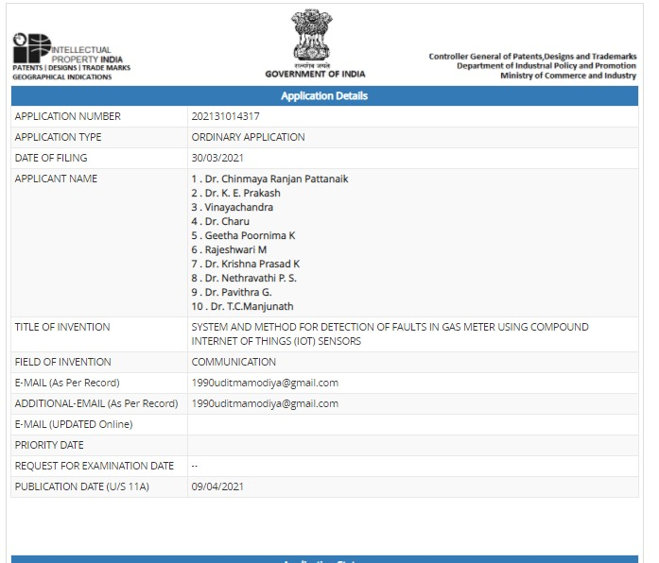

Working Papers:
- Impact of Learning Analytics to Strengthen the Teaching-Learning Experience – A Systematic Study
- The Effect of Cognitive Learning Skill Index on the enhanced learning experiences of the students: A Predictive Analysis.

Membership in Professional Bodies :
- Graduate Student Member – No. 96697260 (Bangalore Section)

Copyright
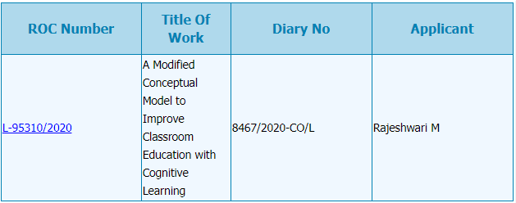

Research Scholar:
Ms. Rajeshwari M
Assistant professor, Department of Computer Science
St Philomena College, Puttur, D.K. 574202 KARNATAKA
&
Research Scholar,
College of Computer Science & Information Science
Srinivas University, City Campus, Mangaluru - 575001

E-mail: rajimuraleedhar@gmail.com, rajimuraleeedhar@spcputtur.org
Personal Website : https://rajimuraleedharrao.blogspot.com
College Website : www.spcputtur.org
University Website: www.srinivasuniversity.edu.in

Profile in Popular Research Work Uploading Sites
ResearchGate | https://www.researchgate.net/profile/Rajeshwari_Muraleedhar
Google Scholar | https://scholar.google.com/citations?user=lknhpBAAAAAJ&hl=en
ORCID | https://orcid.org/0000-0001-9613-4967
Academia | https://independent.academia.edu/RajiM10
SSRN | https://papers.ssrn.com/sol3/cf_dev/AbsByAuth.cfm?per_id=3779205
Mendeley | https://www.mendeley.com/profiles/rajeshwari-rao/
Vidwan | https://vidwan.inflibnet.ac.in/profile/220292

Research Guide:
Dr. Krishna Prasad K.
Associate Professor,
College of Computer Science & Information Science
Srinivas University, City Campus, Mangaluru– 575001
E-mail : krisshnaprasadkcci@srinivasuniversity.edu.in, karanikrishna@gmail.com
Personal Website: www.krishnaprasadk.website
College Website: www.srinivasgroup.com
University Website: www.srinivasuniversity.edu.in

